Inflectional Morpheme

🔠 What is an Inflectional Morpheme?
# Source: AI Source: Provided by: [Data Path: Persons Table -> ID Column: 1, Name_En Column: Motasem Essam] -> From: [Chatgpt (GPT-4-turbo)] on [7/24/2025]
An inflectional morpheme is a bound morpheme that adds grammatical information to a word without changing its core meaning or word class (such as noun, verb, adjective, etc.).

📘 Definition:
# Source: AI Source: Provided by: [Data Path: Persons Table -> ID Column: 1, Name_En Column: Motasem Essam] -> From: [Chatgpt (GPT-4-turbo)] on [7/24/2025]
An inflectional morpheme modifies a word to express tense, number, person, gender, aspect, mood, or comparison, but does not create a new word.

✅ Key Features:
# Source: AI Source: Provided by: [Data Path: Persons Table -> ID Column: 1, Name_En Column: Motasem Essam] -> From: [Chatgpt (GPT-4-turbo)] on [7/24/2025]
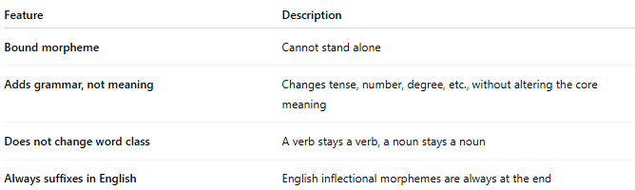
Feature | Description
Bound morpheme | Cannot stand alone
Adds grammar, not meaning | Changes tense, number, degree, etc., without altering the core meaning
Does not change word class | A verb stays a verb, a noun stays a noun
Always suffixes in English | English inflectional morphemes are always at the end

📚 Examples of Inflectional Morphemes in English:
# Source: AI Source: Provided by: [Data Path: Persons Table -> ID Column: 1, Name_En Column: Motasem Essam] -> From: [Chatgpt (GPT-4-turbo)] on [7/24/2025]
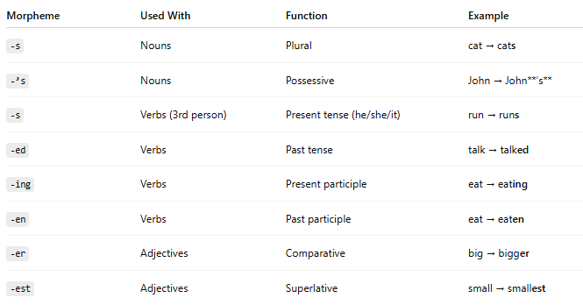
Morpheme | Used With | Function | Example
-s | Nouns | Plural | cat → cats
-’s | Nouns | Possessive | John → John**’s**
-s | Verbs (3rd person) | Present tense (he/she/it) | run → runs
-ed | Verbs | Past tense | talk → talked
-ing | Verbs | Present participle | eat → eating
-en | Verbs | Past participle | eat → eaten
-er | Adjectives | Comparative | big → bigger
-est | Adjectives | Superlative | small → smallest
📌 Total in English: There are 8 inflectional morphemes in modern English.

❗ Not Derivational:
# Source: AI Source: Provided by: [Data Path: Persons Table -> ID Column: 1, Name_En Column: Motasem Essam] -> From: [Chatgpt (GPT-4-turbo)] on [7/24/2025]
Unlike derivational morphemes (which change the meaning or class of a word), inflectional morphemes preserve the base word's core meaning and category.
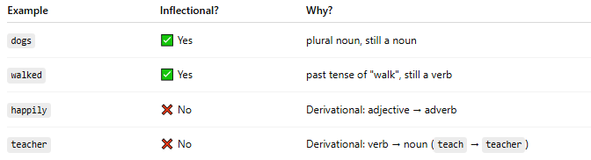
Example | Inflectional? | Why?
dogs | ✅ Yes | plural noun, still a noun
walked | ✅ Yes | past tense of "walk", still a verb
happily | ❌ No | Derivational: adjective → adverb
teacher | ❌ No | Derivational: verb → noun (teach → teacher)

✅ Summary:
# Source: AI Source: Provided by: [Data Path: Persons Table -> ID Column: 1, Name_En Column: Motasem Essam] -> From: [Chatgpt (GPT-4-turbo)] on [7/24/2025]
- Inflectional morphemes are suffixes that add grammatical meaning.
- They don’t change the basic meaning or word class.
- They are always bound and always suffixes in English.

